MECE Report

# Executive Summary

The purpose of this report is to analyze the sales data from various categories, customers, products, and orders to derive actionable insights and recommendations. Key findings include the identification of top-performing products and customer segments, as well as optimization opportunities in the supply chain.

# Introduction

This analysis is based on a comprehensive dataset encompassing categories, customers, employees, order details, orders, products, shippers, and suppliers. The datasets provide a broad view of the company's operations, customer base, and sales performance.

## Objectives and Goals

- Understand Sales Trends and Performance: Analyze the sales data to identify trends over time, including peak sales periods and low-performing periods.  
- Identify Key Drivers of Revenue and Profitability: Determine which products, categories, and customer segments contribute most to revenue and profitability.  
- Provide Strategic Recommendations: Based on the analysis, offer actionable recommendations to optimize operations, improve customer satisfaction, and enhance profitability.  
- Highlight Operational Efficiency: Evaluate the supply chain, logistics, and production processes to identify bottlenecks and opportunities for improvement.  
- Assess Financial Health: Analyze the financial data to ensure sustainability and identify potential risks.

## Methodology and Approach

The analysis involves data cleaning, exploratory data analysis, visualizations, and statistical analysis.

# Market Analysis

## Market Size and Growth Trends

The total market size was evaluated by summing up the sales from all orders. Monthly sales trends were analyzed to identify growth patterns over time.

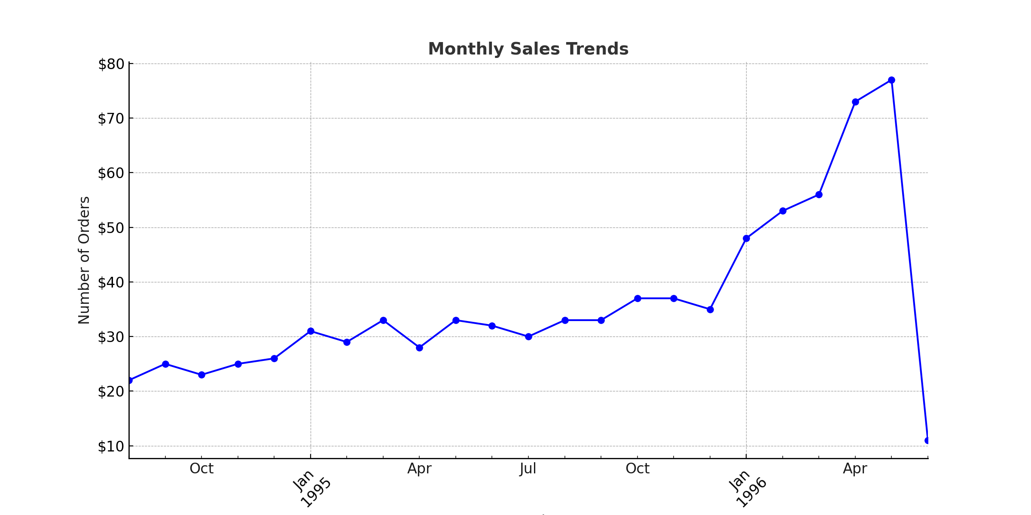

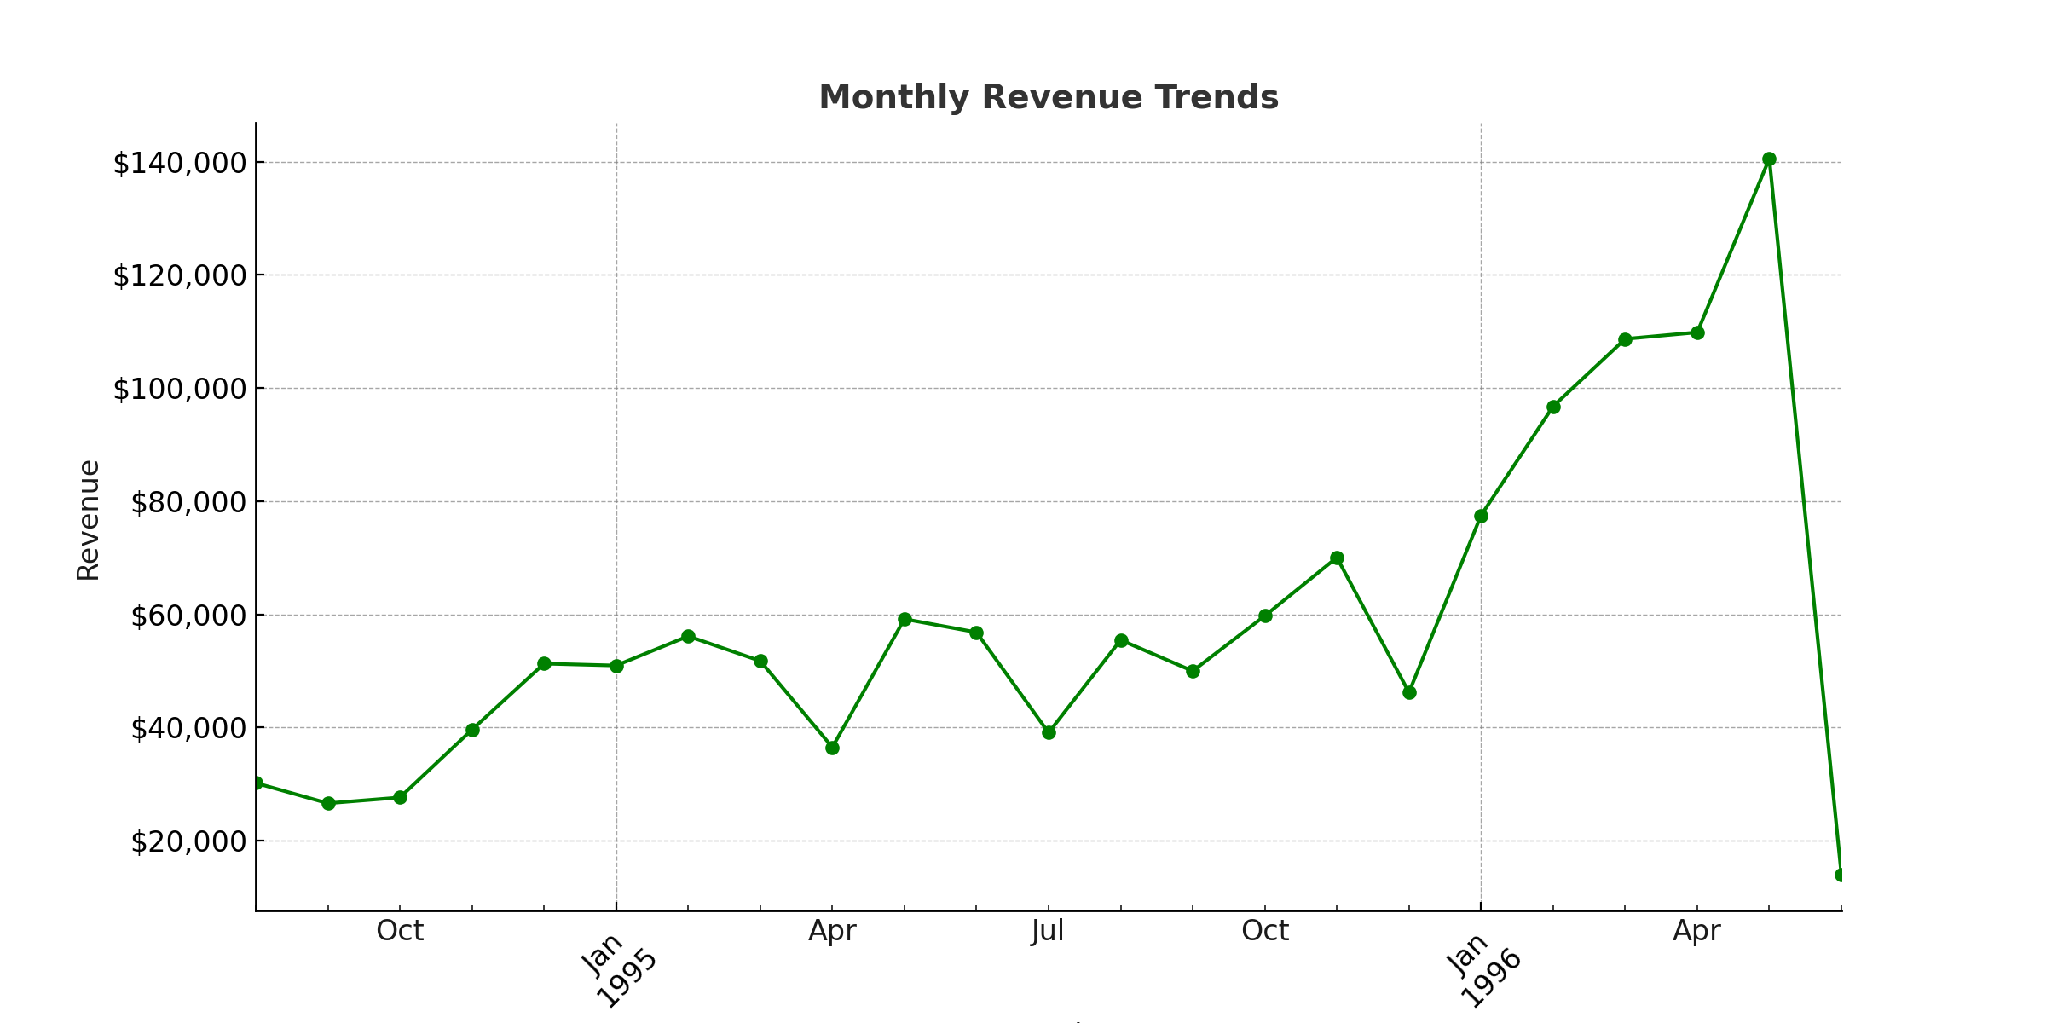

## Competitive Landscape

The number of products and categories offered by different suppliers were examined to understand the competitive landscape.

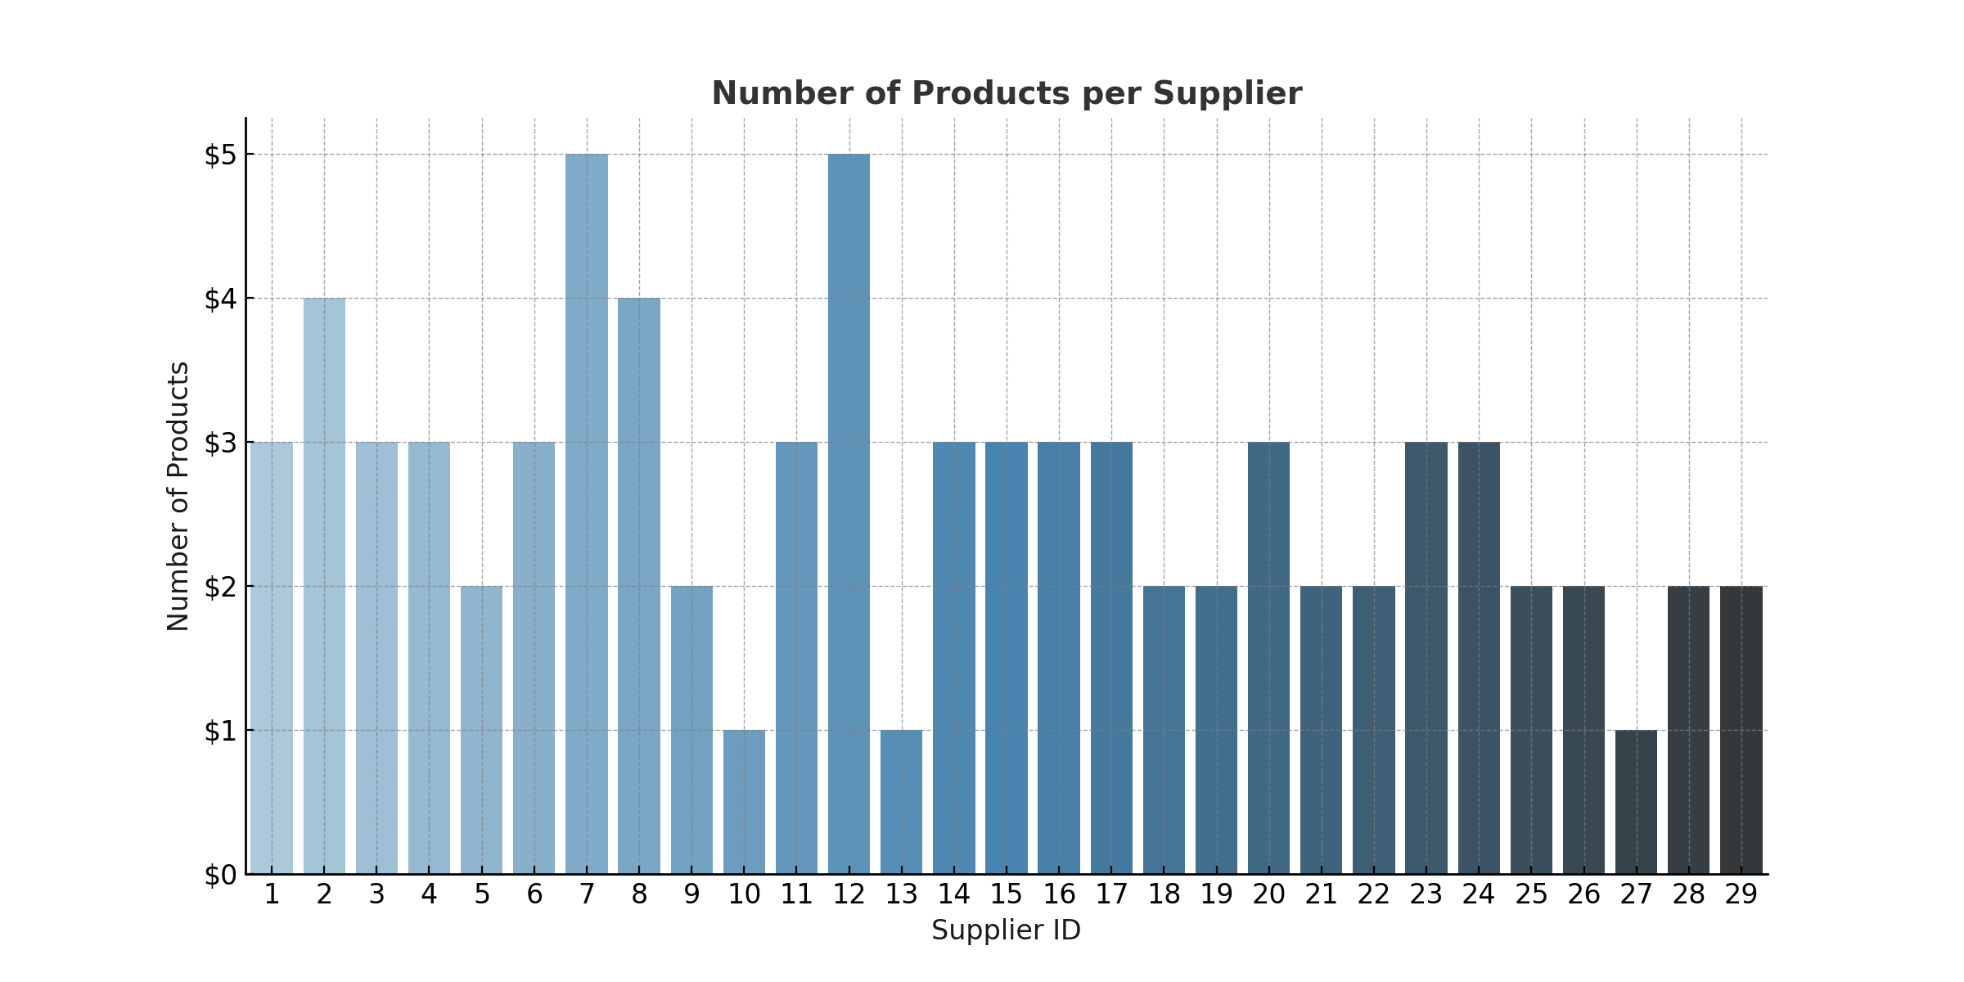

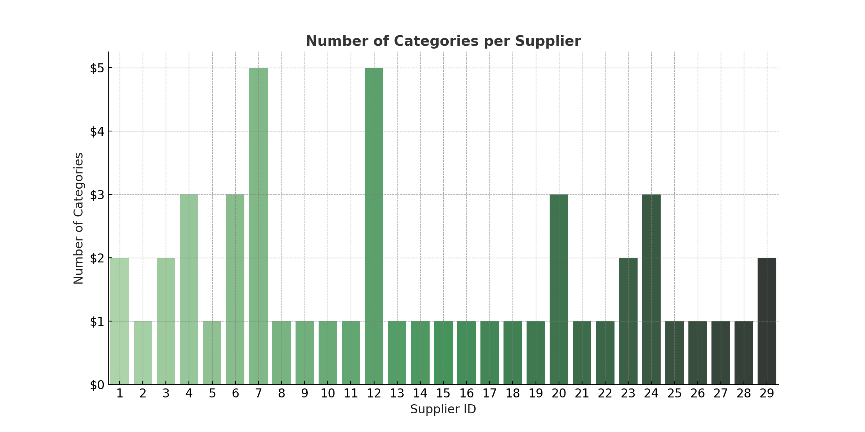

## Customer Segments and Demographics

Customers were segmented based on their purchase behavior and demographic information.

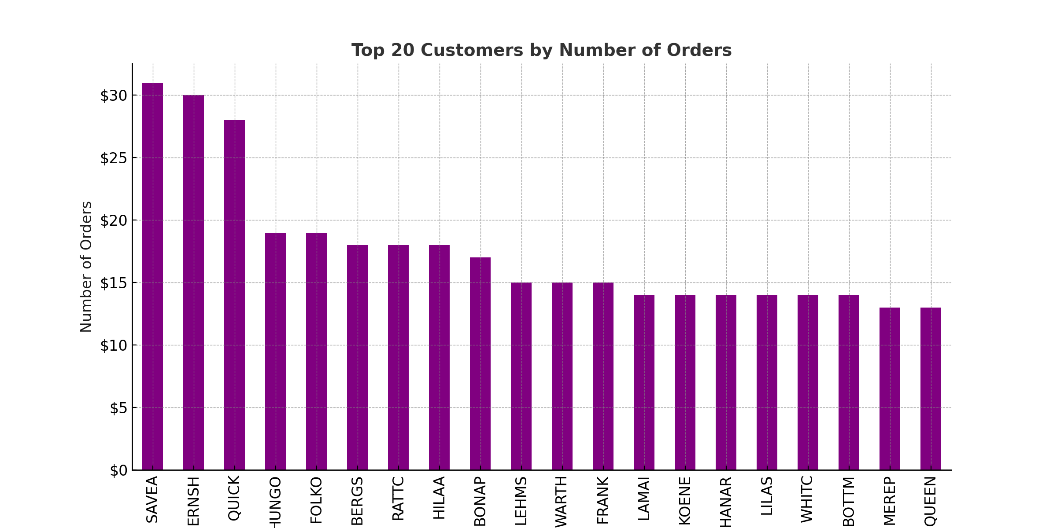

## Key Market Drivers and Challenges

Factors driving sales and challenges faced were identified through a SWOT analysis.

|  |  |  |  |
| --- | --- | --- | --- |
| Strengths | Weaknesses | Opportunities | Threats |
| Wide range of products Strong supplier relationships | High operational costs Dependency on key suppliers | Expanding into new markets Introducing new product lines | Market competition Economic downturns |

# Financial Analysis

## Revenue and Profitability Trends

Revenue and profitability trends were analyzed to understand the financial performance.



# Detailed Insights and Findings

## Key Trends and Patterns

The analysis revealed several key trends and patterns in the data. For instance, certain product categories consistently outperformed others in terms of sales. Seasonal trends were also observed, with peak sales occurring during specific months.

## Anomalies and Outliers

The analysis also identified several anomalies and outliers. These include unusually high sales figures for certain products, which could indicate a special promotion or bulk purchase.

# Conclusion

The analysis provided comprehensive insights into the sales data, highlighting key trends and identifying potential areas for improvement. By focusing on top-performing products and customer segments, and optimizing the supply chain, the company can drive further growth and profitability.